N.V. Sandeep Kumar

192372026

MODULE-3

PL/SQL :-

PRINT STATEMENT :-

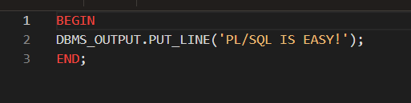

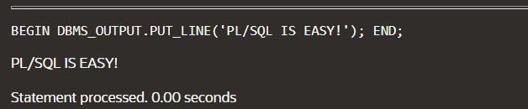

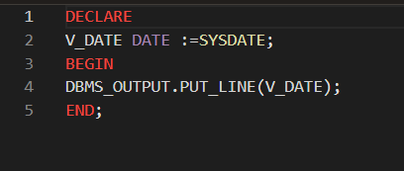

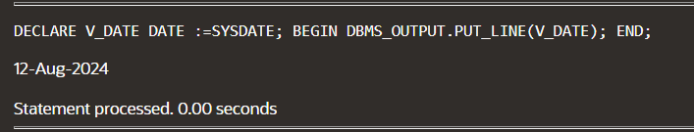

CREATE A TABLE

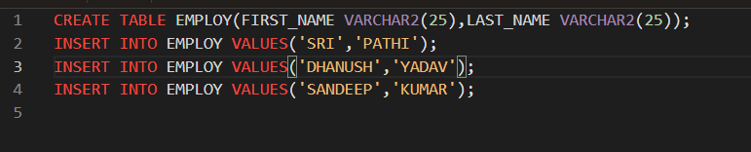

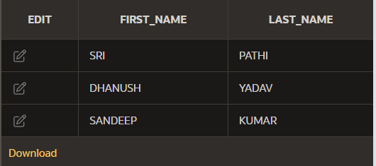

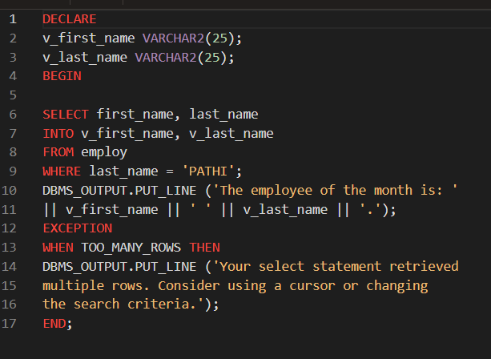



ADDING OF TWO NUMBERS :-

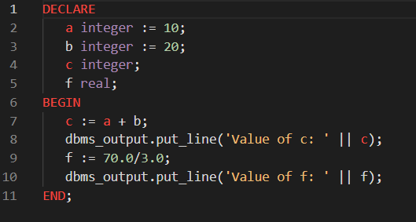



FIND THE GREATEST AMONG TWO NUMBERS :-

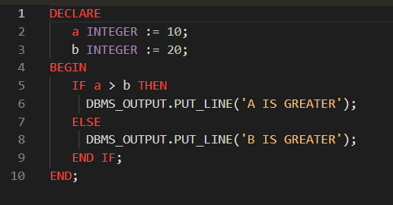



RADIUS :-

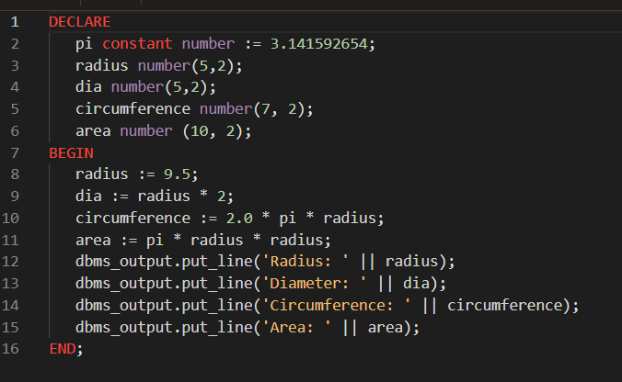

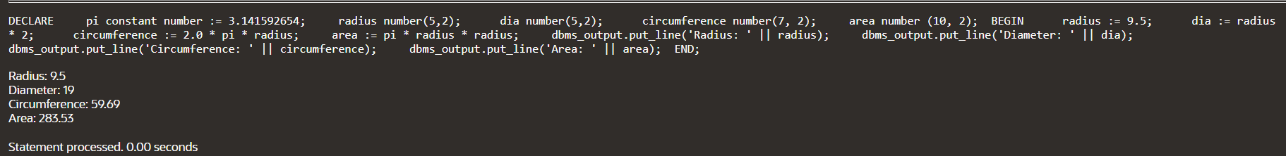

FOUND THE NUMBER OF WORDS AND LETTERS :-

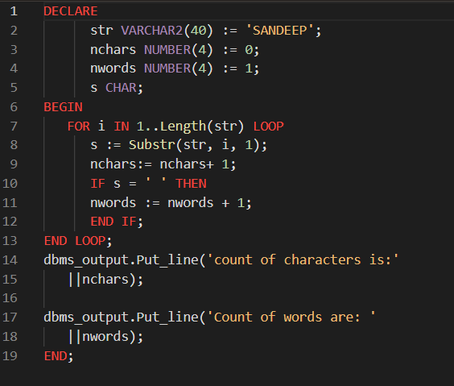

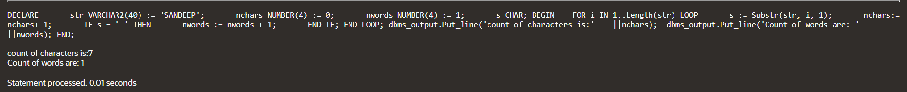

SUM OF NUMBERS :-

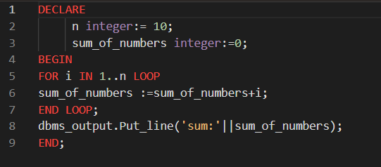



FUNTIONS :-

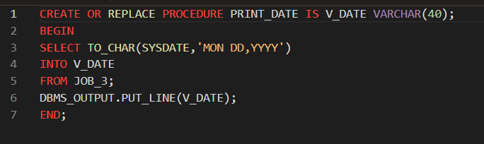



PROGRAMS :-

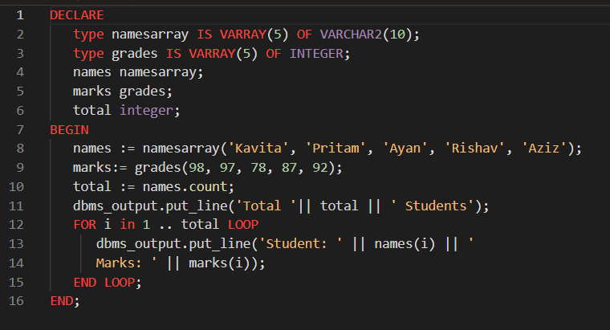

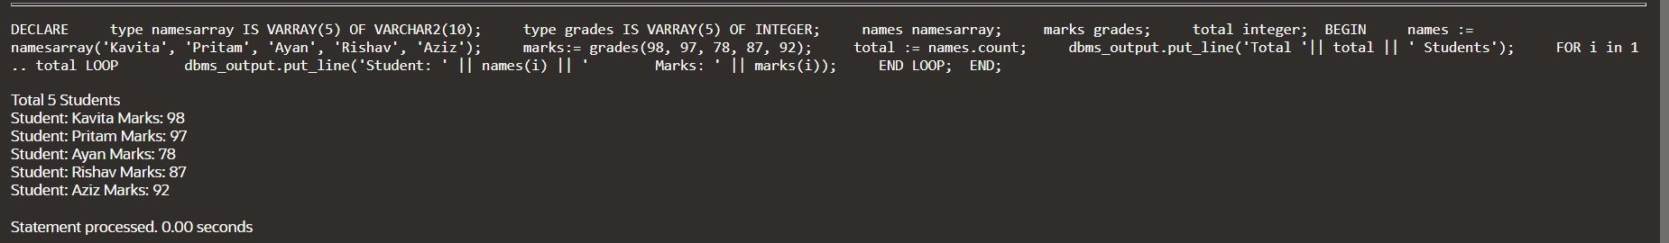

USING IF AND ELSEIF :-

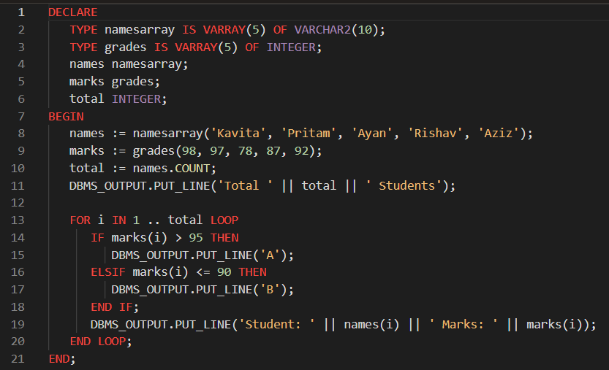

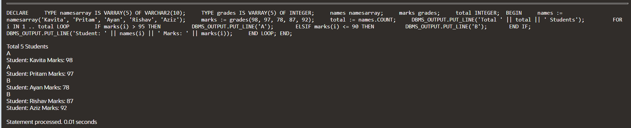

USING IF AND ELSE CONDITION AND PRINT THE NUMBER OF EVEN NUMBERS AND ODD NUMBERS :-

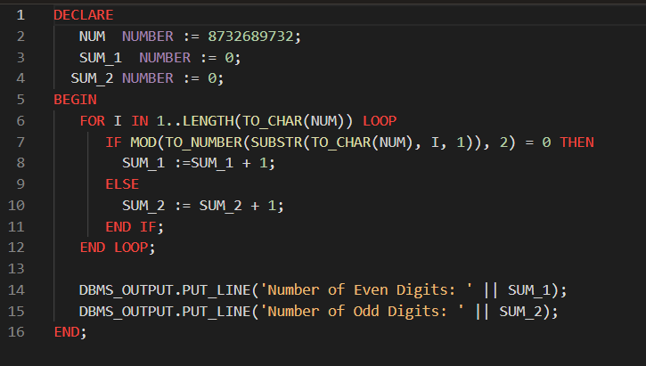

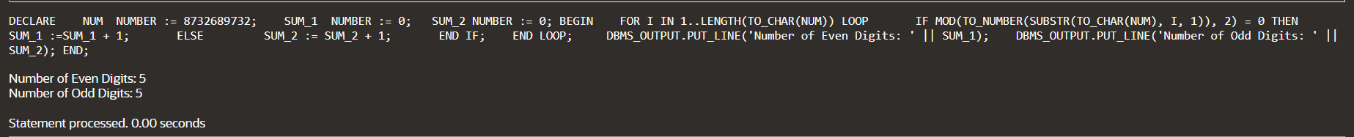

CALCULATOR PROGRAM :-

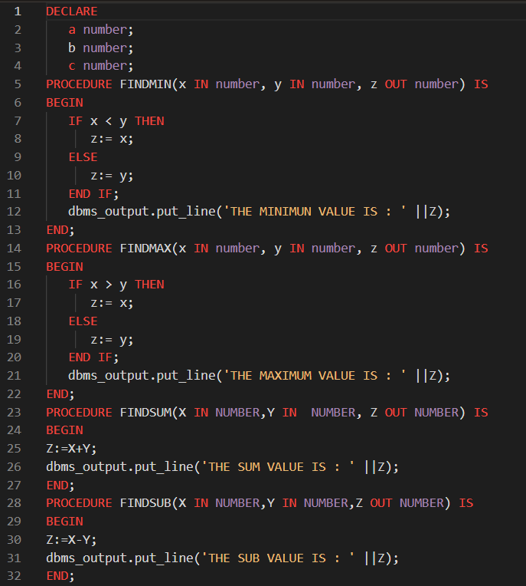

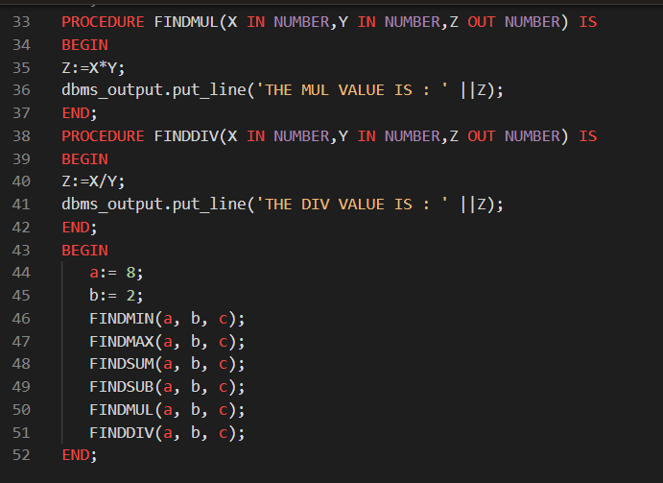

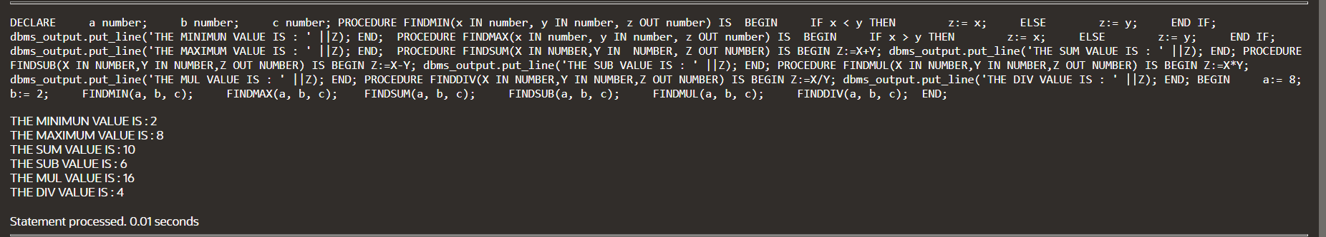

2-1 :-

INITILIZING THE VARIABLES :-

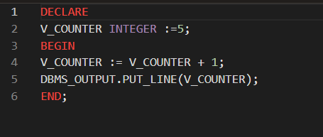

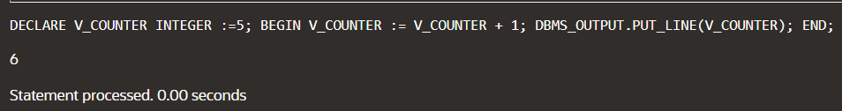

ASSIGNING VALUES IN THE EXECUTABLE SECTION :-

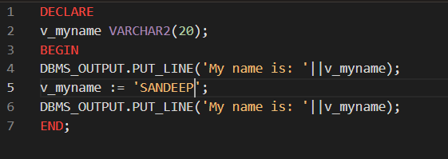



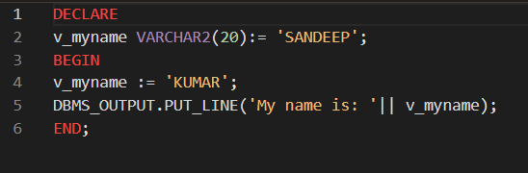

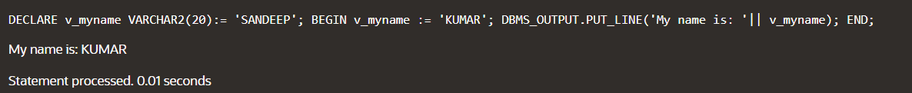

PASSING VARIABLES AS PARAMETERS TO PL/SQL SUBPROGRAMS :-

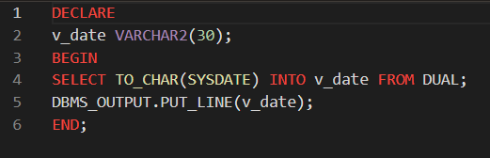

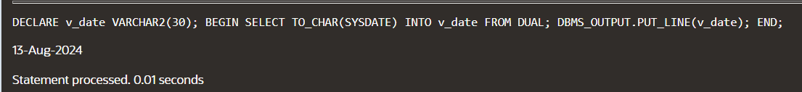

ASSIGNING VARIABLES TO PL/SQL SUBPROGRAM OUTPUT :-

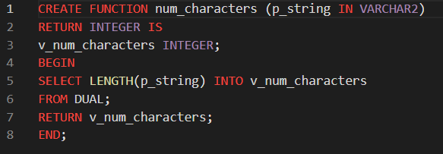



LENGTH OF STRING :-

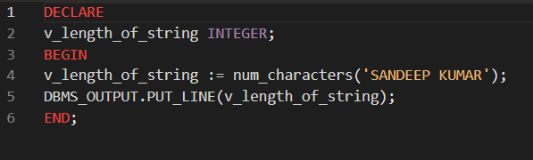



PROGRAMS :-

FACTORIAL (RECCURSSION) :-

PROGRAM :-

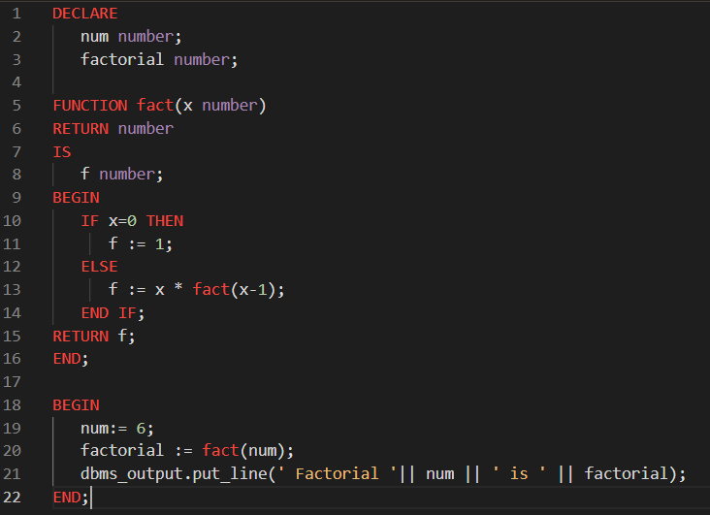

OUTPUT :-



MAX NUMBERS (2-NUMBERS) :-

PROGRAM :-

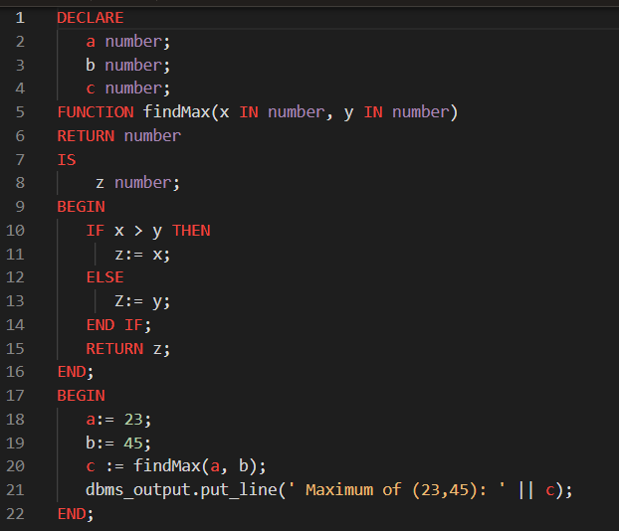

OUTPUT :-



FIBONACCI SERIES (RECCURSION) :-

PROGRAM :-

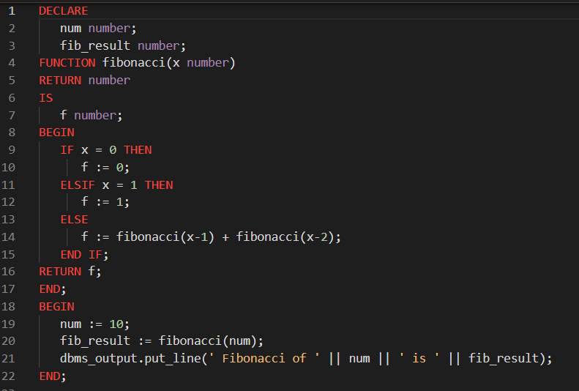

OUTPUT :-



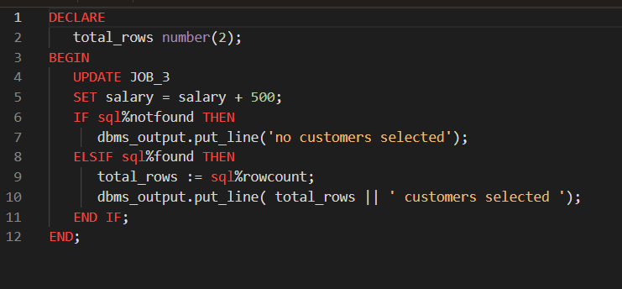



EMPLICITY :-

UPDATE SALARY IN THE GIVEN TABLE :-

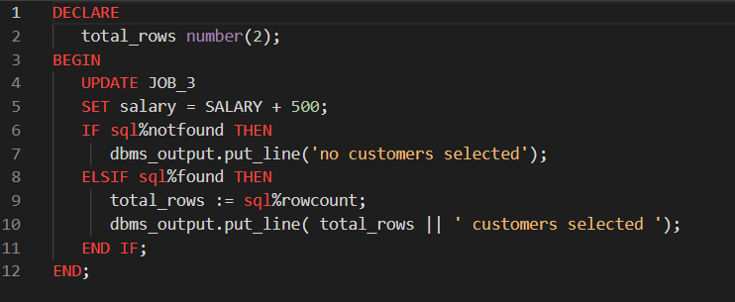

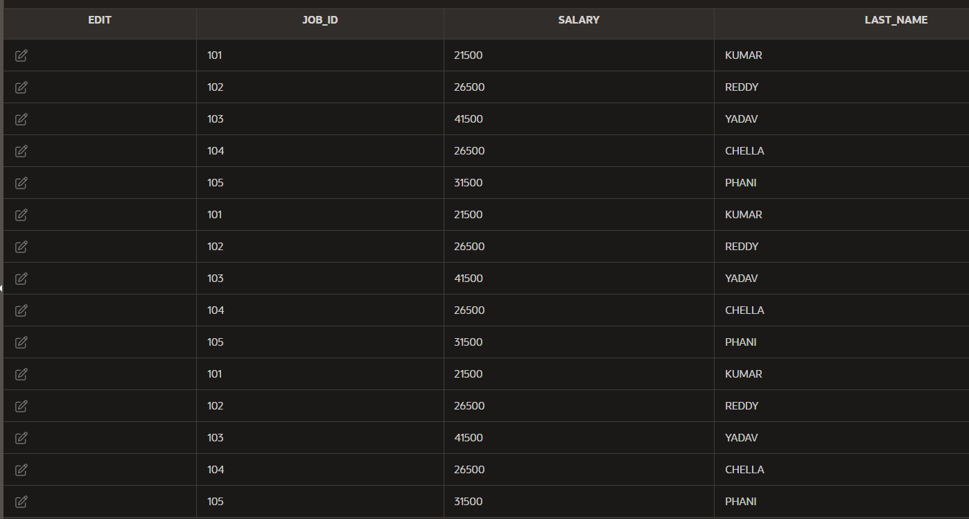

OUTPUT :-



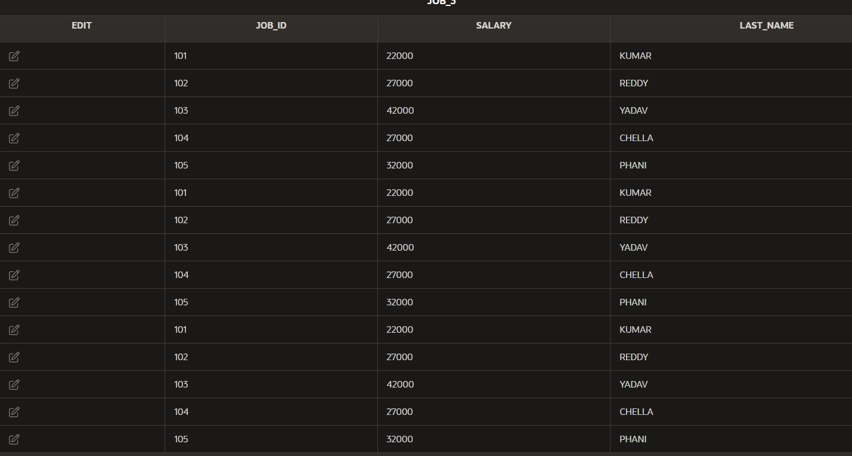

CREATE TABLE FOR THE FETCHING THE DATA :-

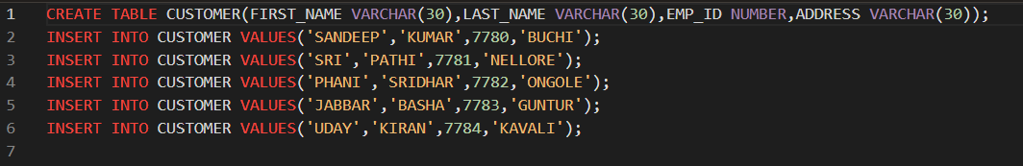

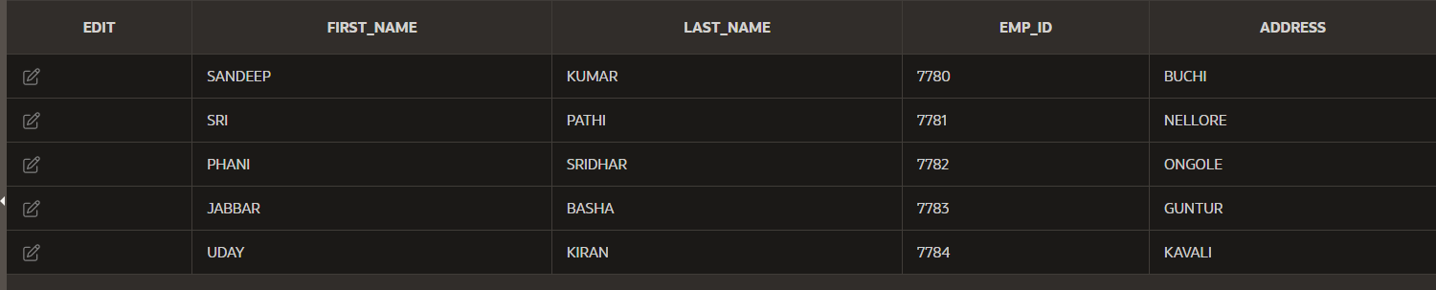

FETCHING DATA FROM THE TABLE :-

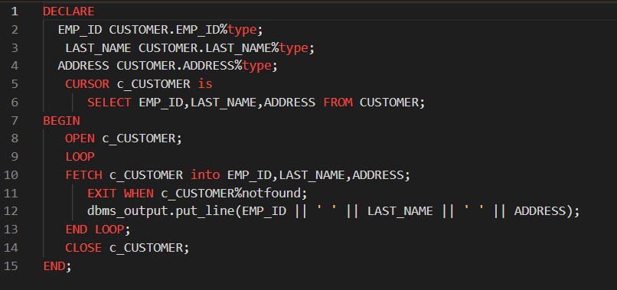

OUTPUT :-

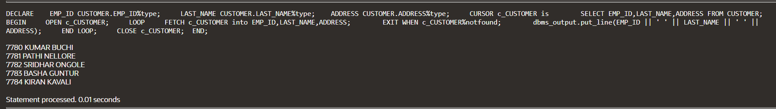

**NO.OF ROWS USING FUNCTIONS:**

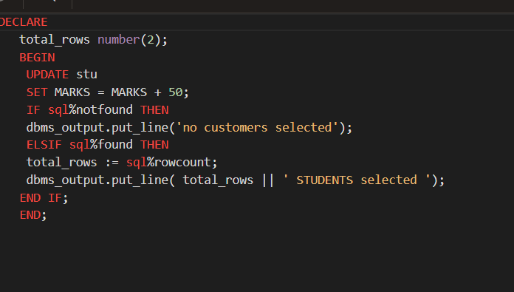

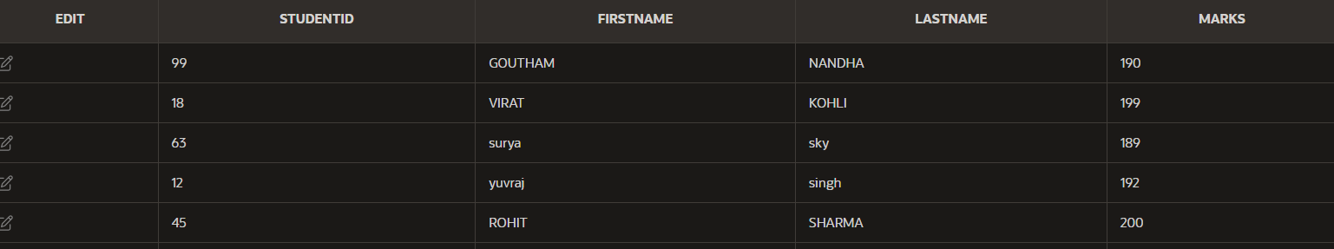

SELECT ROWS FROM TABLE:

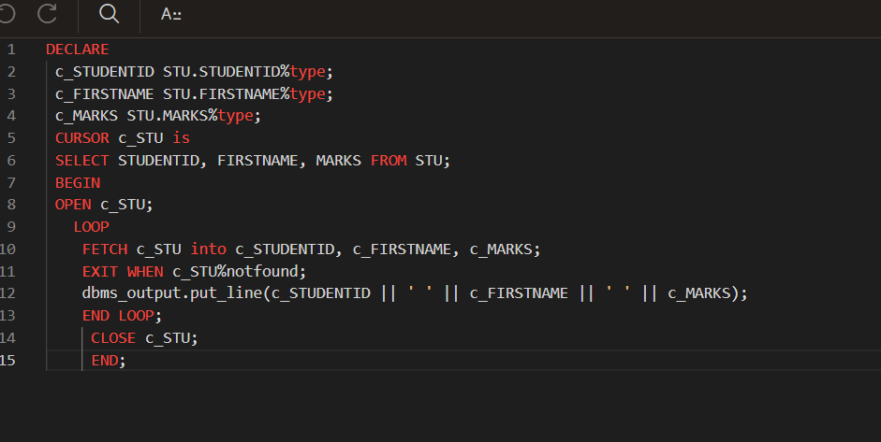

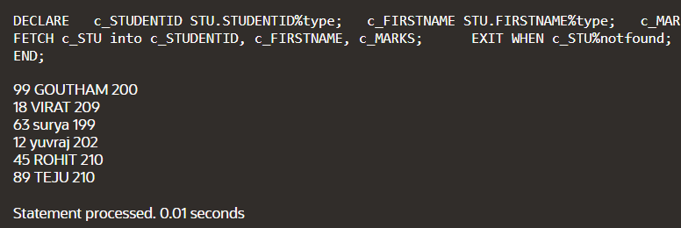

3-1 :-

INSERT :-

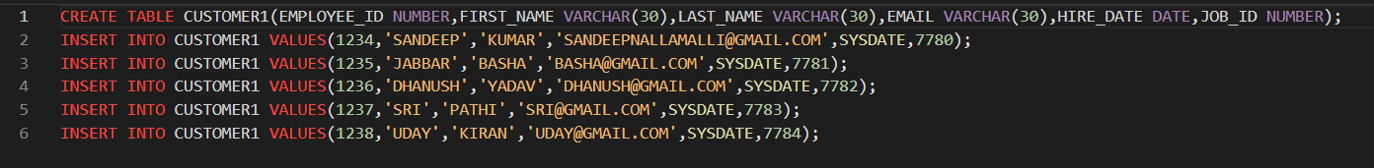

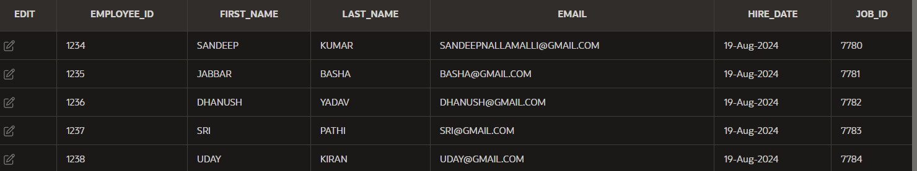

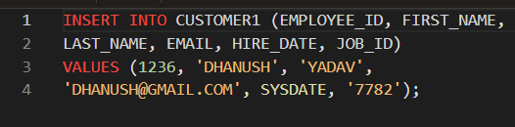



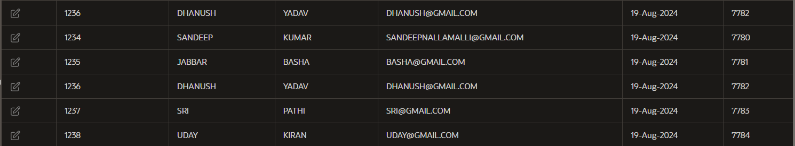

UPDATE SYNTAX :-

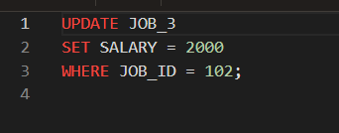

BEFORE TABLE :-

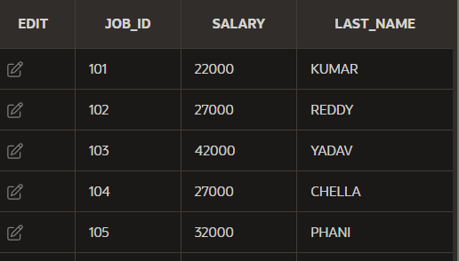

AFTER TABLE :-

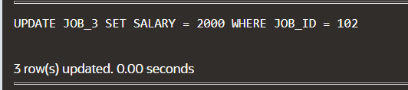

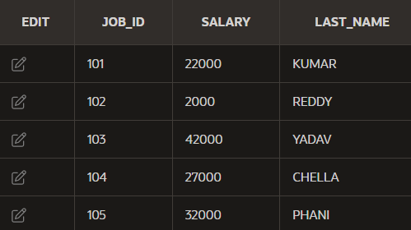

MERGE USAGE AND SYNTAX :-

CREATE TWO TABLES :-

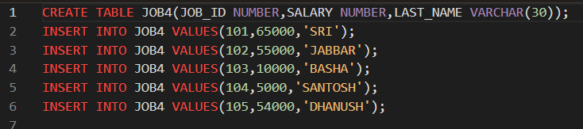

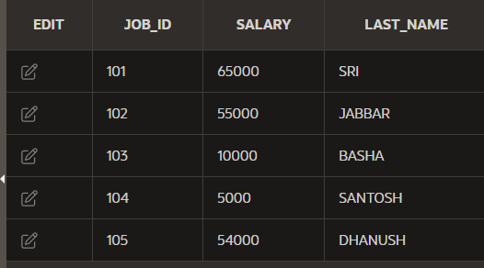

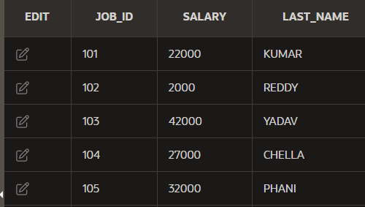

AFTER THAT MERGE :-

